AutoISF Fork —Brief Operations Manual

AIM of the program. [a personal use example of ideas]

The aim is to make the requirement for intervention very minimal, given still the expectation of at least intermittent bolus calculation. This represents a lesser goal than the “boost” Variant aAPS programme, which I think really aims at no bolus.

Although the internal code automations do switch profiles and set temp targets these can be set individually as well if necessary and particularly if there is a concern about overall excess strength causing hypoglycemia or various conditions [such as steroids, hormones and so on] interfering in the last few days or weeks,

It is simple enough to switch the “high and low” profiles used by the program. Also, setting “MJ” types from List1 [or States] sets either 3, 2 , or 1 day of more gentle criteria for changing profiles, setting Steroid profiles [first set Kotlin MJ and Steroid buttons] from List1 sets more aggressive changes during the day.

Introduction: Most significant new features [↑ TOC]
This is the plain-language companion to the full AutoISF Operations Manual -- same section numbering, same headings, same settings/reference tables, but each subsection here is one short paragraph explaining what it does and why it matters, instead of the full technical detail. Use this to get oriented quickly; use the full manual [or Plain Language manual] when you need the actual mechanism, thresholds, or code references.
This manual concentrates on the operational changes that most distinguish this AutoISF fork from stock AAPS and that are most likely to affect daily use:

Screenshots
Real device screenshots (Virtual, 24 Aug 2026). Small thumbnails floated beside the relevant Introduction paragraphs link here -- click one to jump to its full-size copy, or just scroll through them below in one place.

GUI display changes.img_overview_stacked
This graph is always the primary time-aligned display Also reachable via a direct TT-code Secondary graphs (graphs 1-4). Graph 5 is a dedicated main-sized comparison panel Gesture and remote triggers. A basal-area long-press cycles the main graph's display preset and controls the quick visibility of empirical carb line 1. An IOB-area long-press toggles SMB labels, resets the basal display preset to normal [↑ TOC]

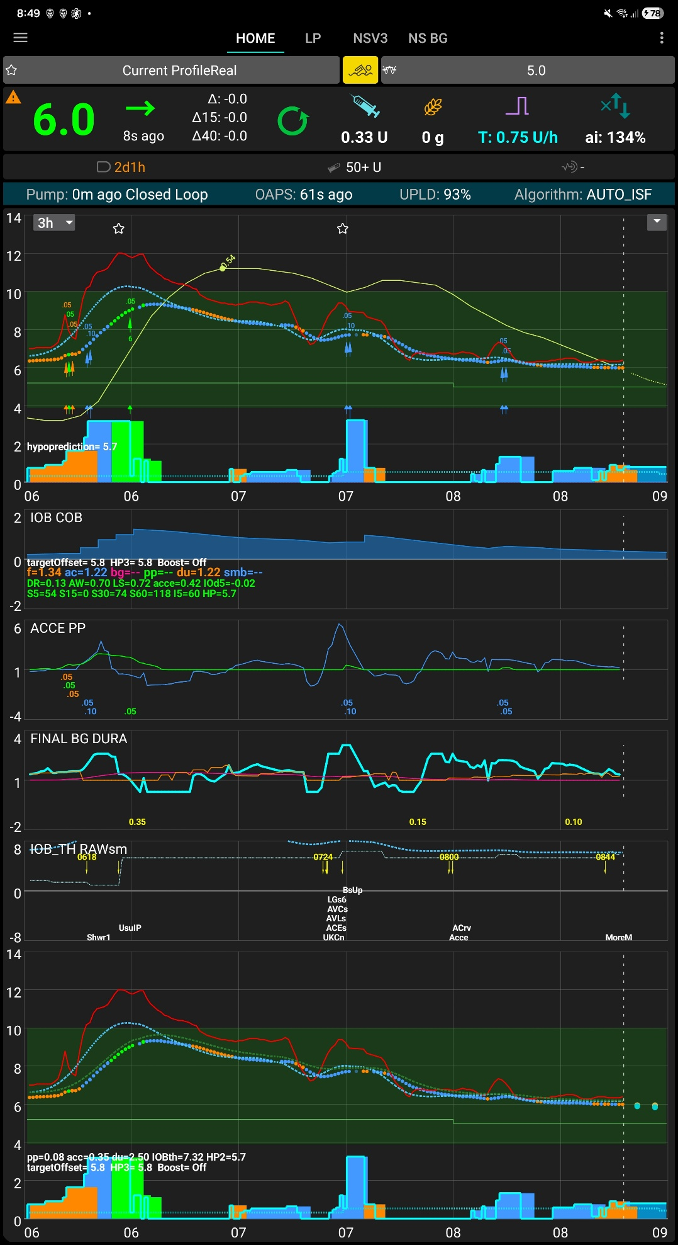
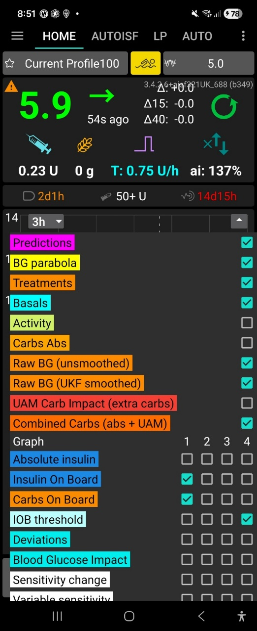
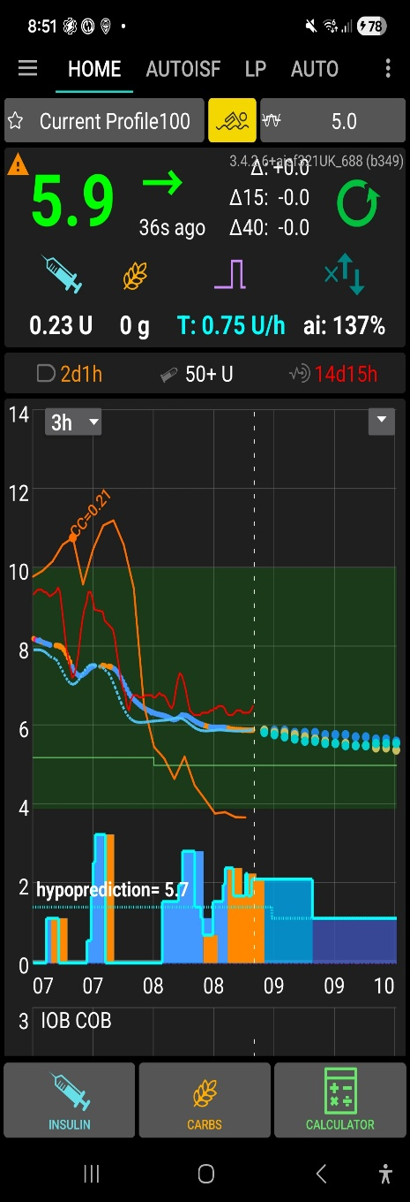
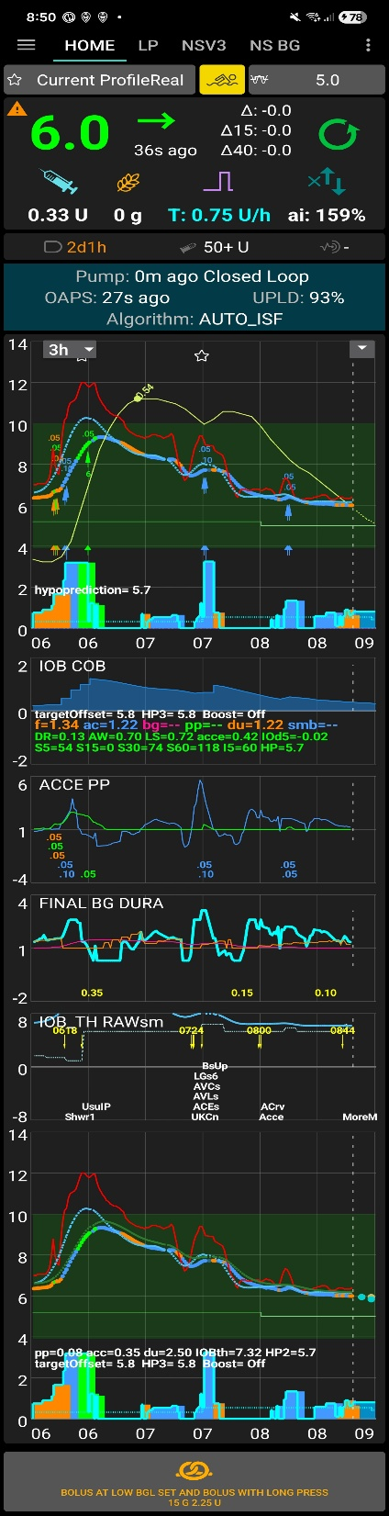
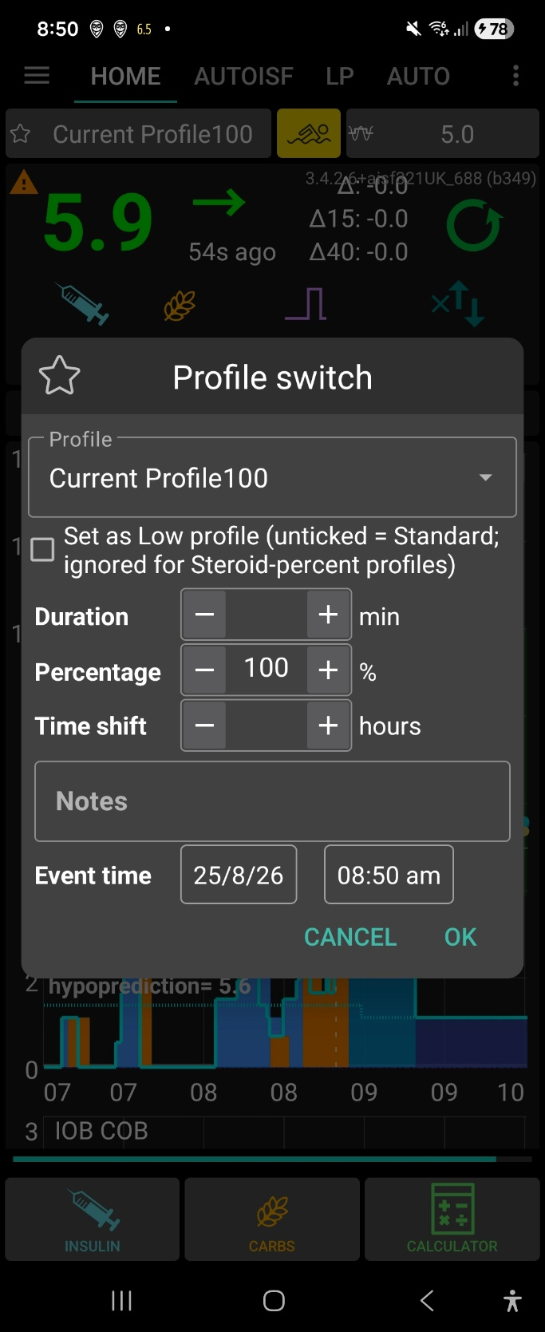
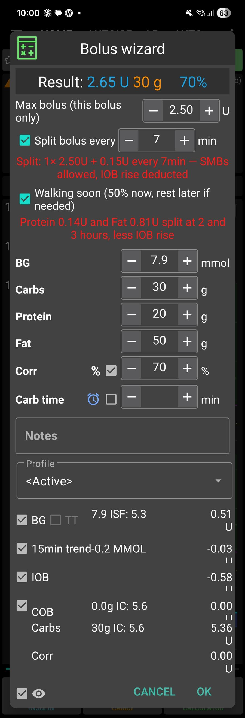

Bolus wizard: split-bolus + Walking soon [↑ TOC]

- Full description of the bolus calculator changes; split and delayed bolus, safer calculation;
Changes to bolus calculator with addition,s modificationeg
Initial screen and live calculation., carbs, protein, fat . Protein and fat are not included in the immediate total
Manual split-bolus if bolus over maximum bolus, remainder split

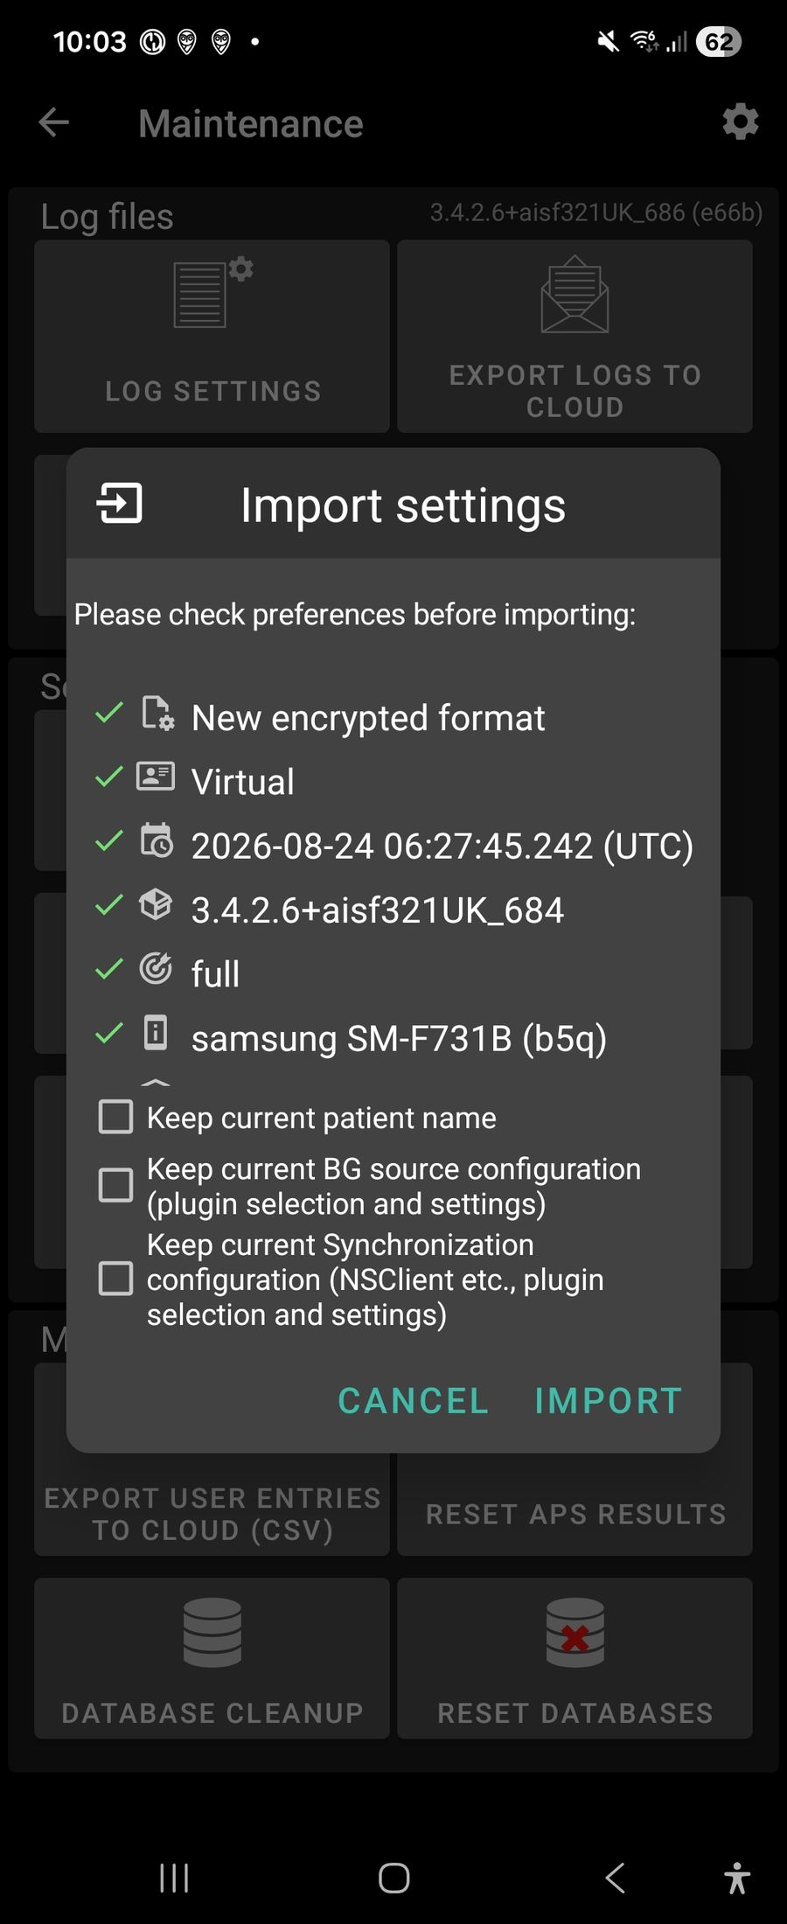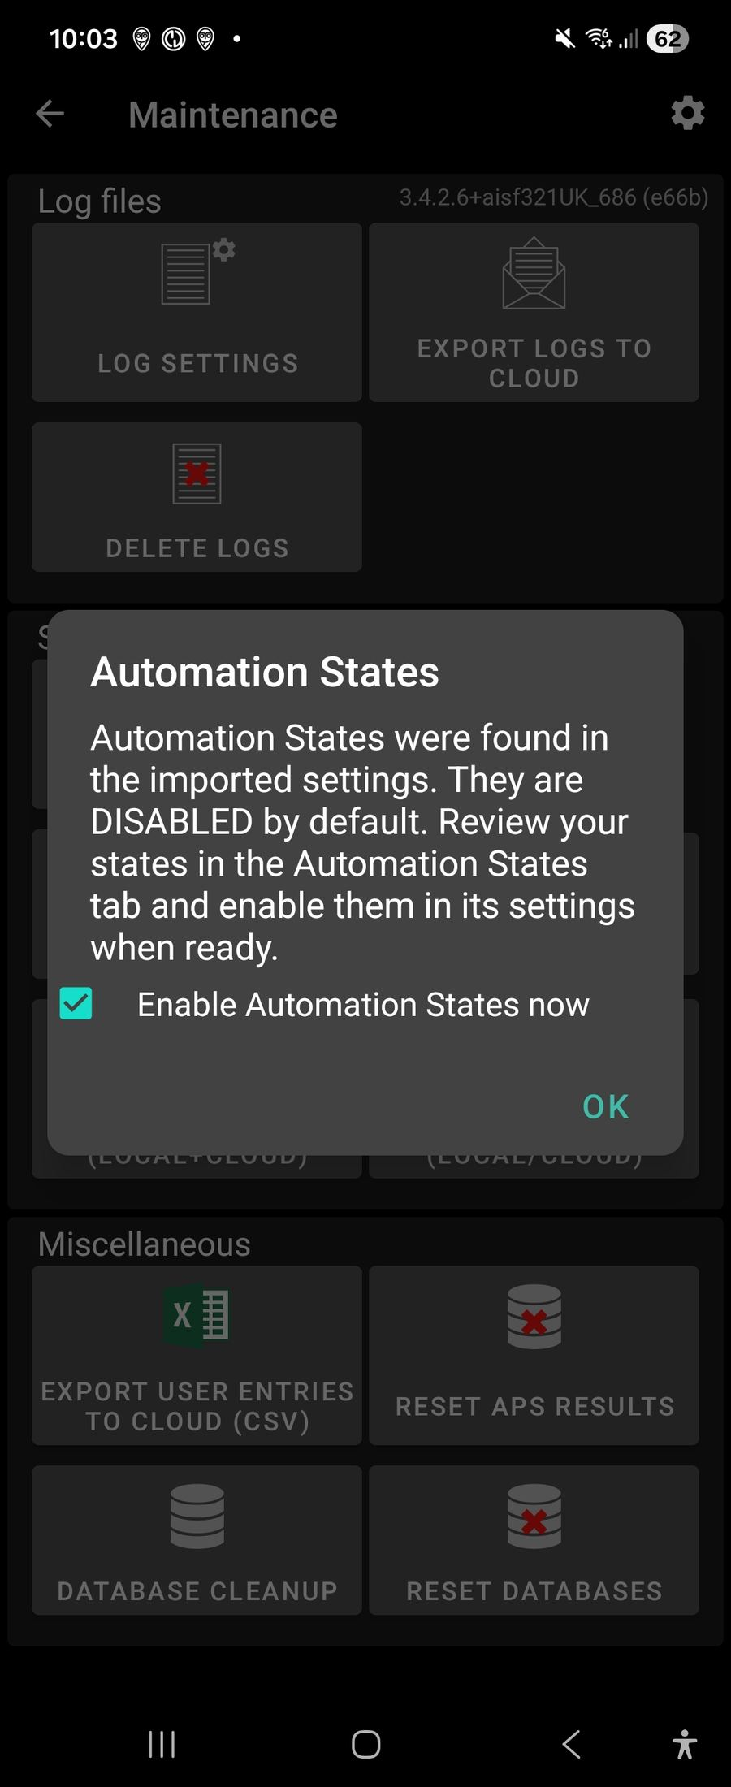

Import settings, with Keep-current checkboxes [↑ TOC]

- Settings Import Features — Especially With States.
Four “Keep current…” checkboxes not present in stock AAPS
Automation States are force-disabled after every import, requiring confirm
Import restores states wholesale — where “states I never made myself” can come from

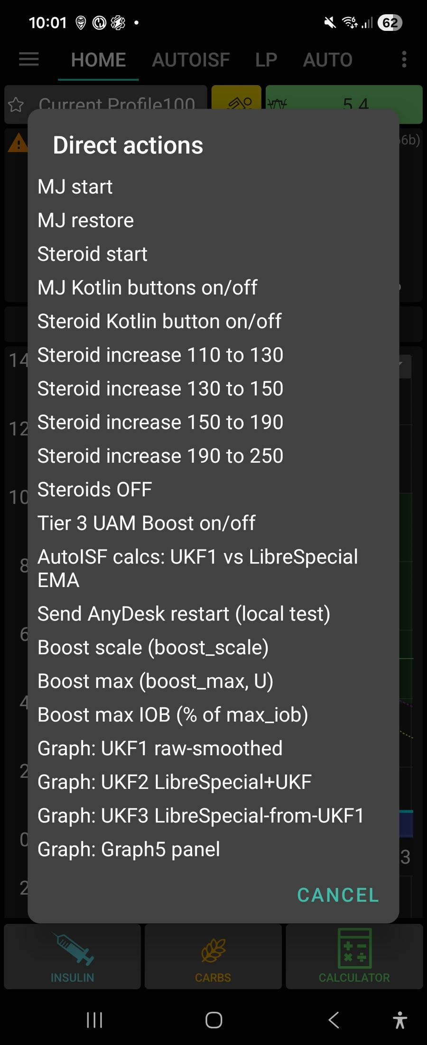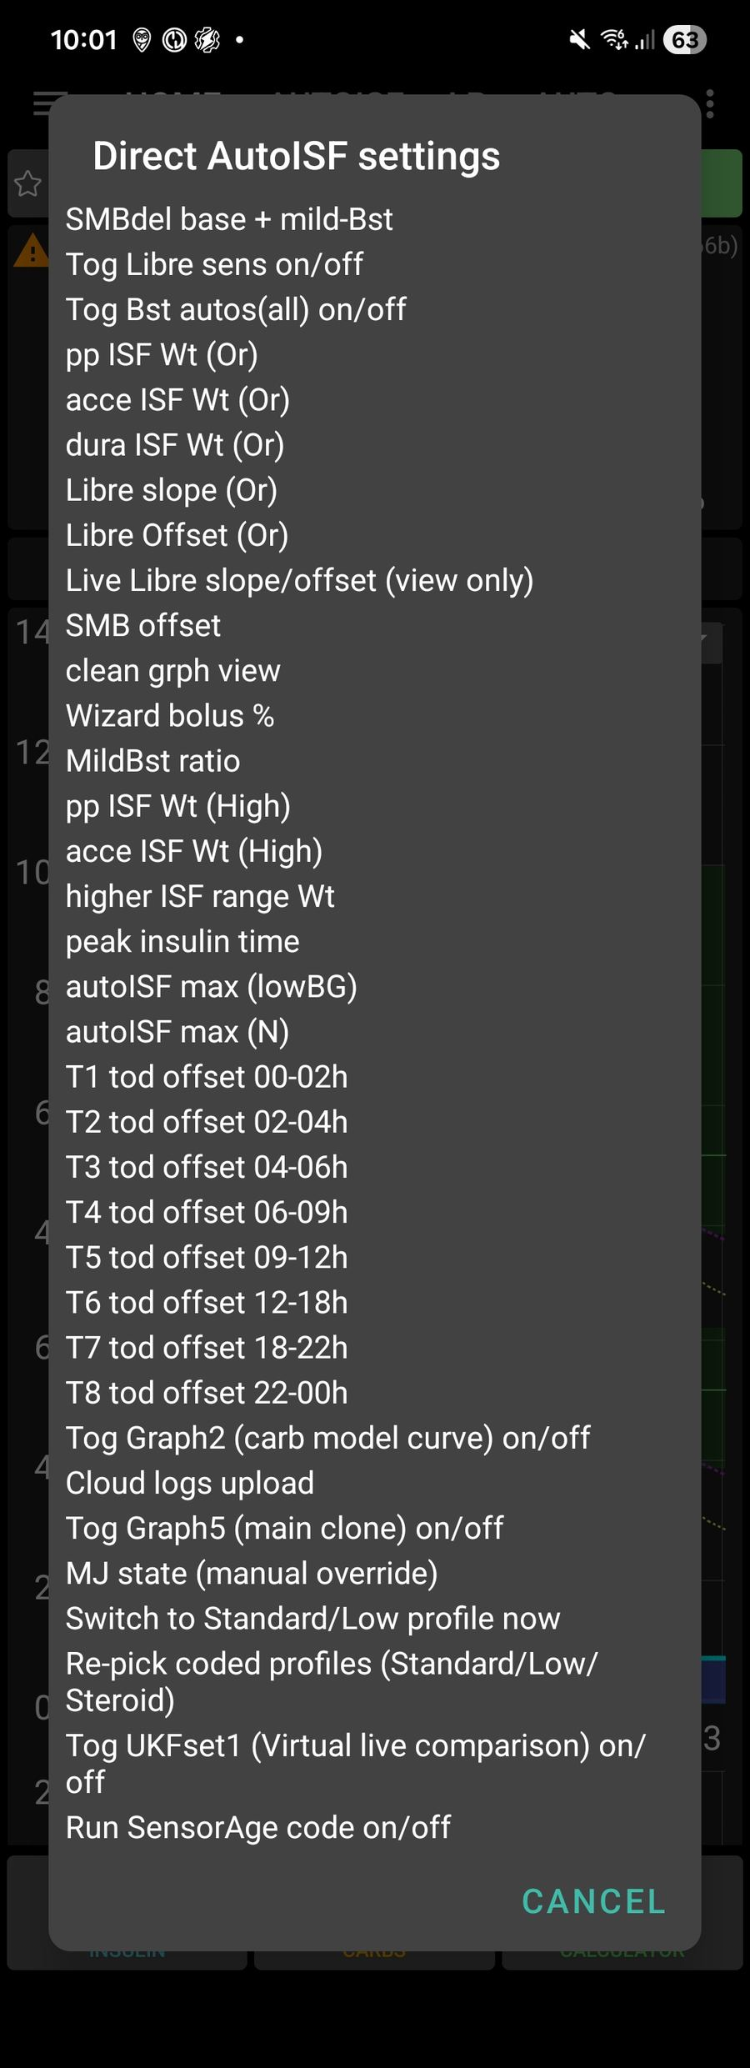
List 1 -- Direct AutoISF settings [↑ TOC]


- Lists 1 and 2: full descriptions; rapid access to settings
Double-tap the IOB area to open List 1. Double-tap the basal-rate area to open List 2
The outer list shows setting names ; for setting preferences and some functions, with confirmation.
On AAPSClient preferences are not changed locally, so confirmation creates the matching five-minute custom temporary-target code for the pump to receive, apply and cancel.

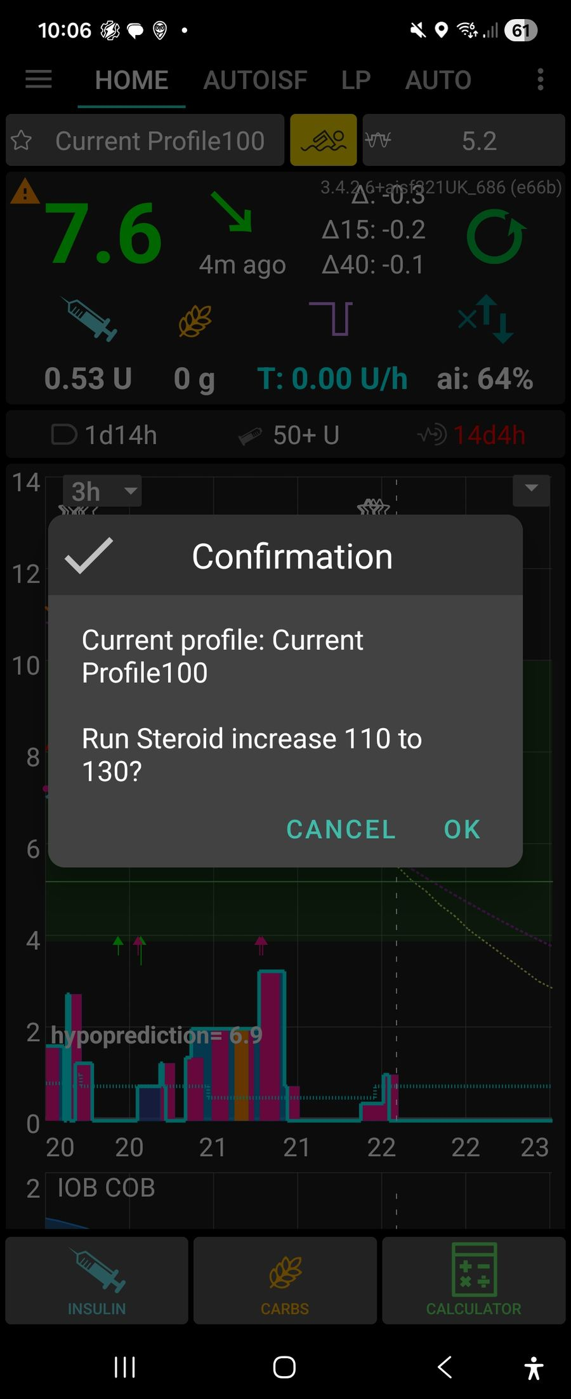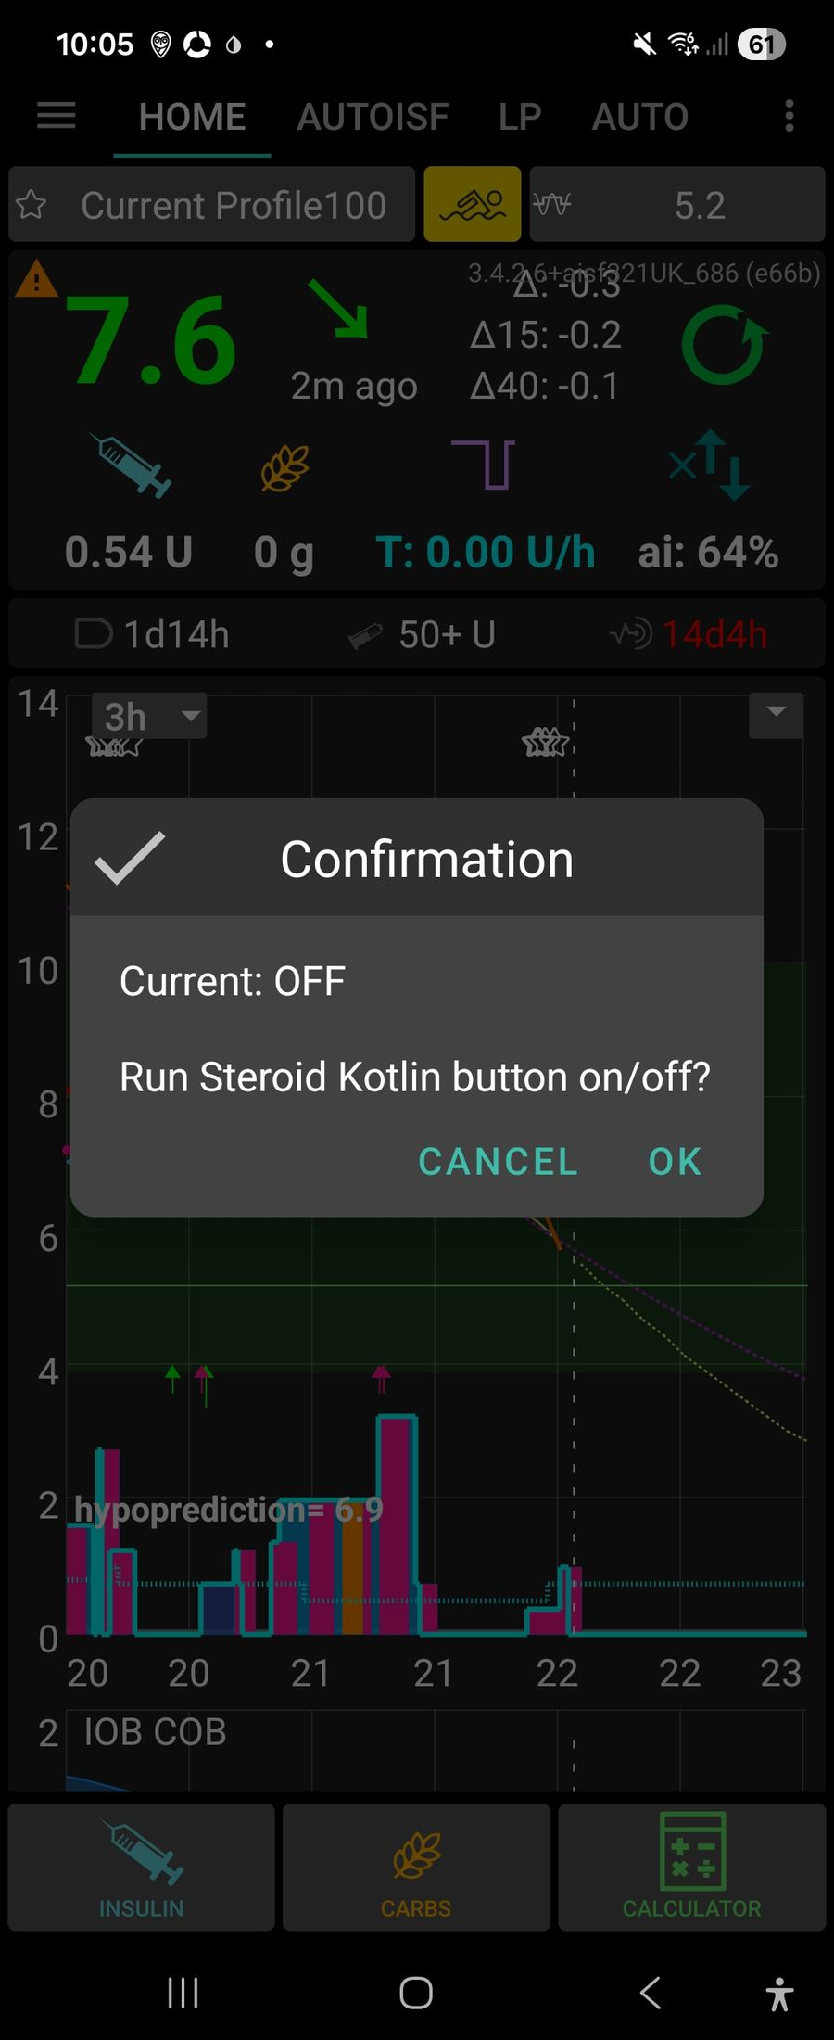
Steroid Kotlin button on/off confirmation [↑ TOC]
MJ Kotlin buttons on/off confirmation [↑ TOC]
List 2 -- Direct actions [↑ TOC]

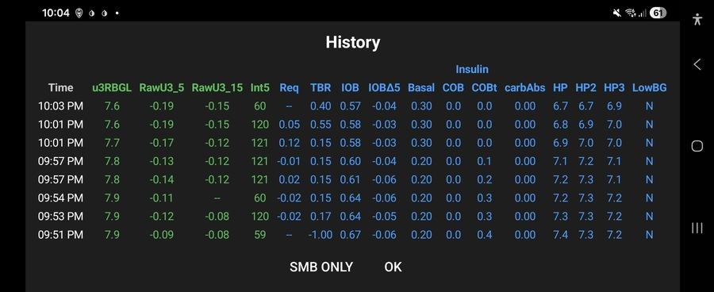
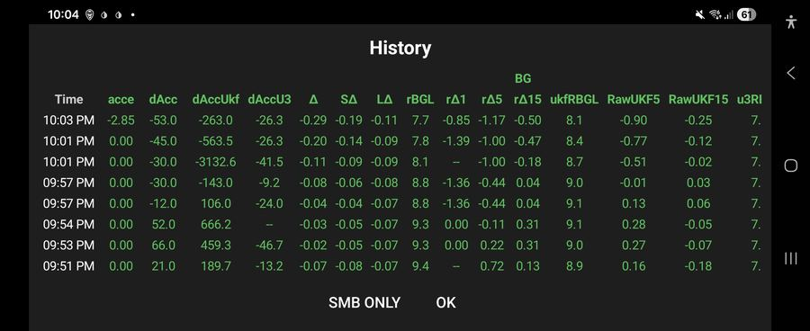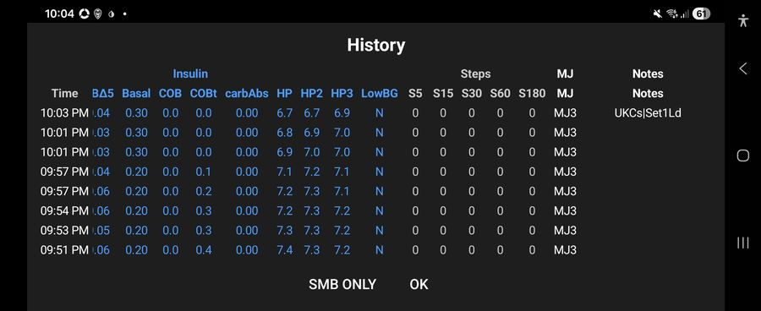
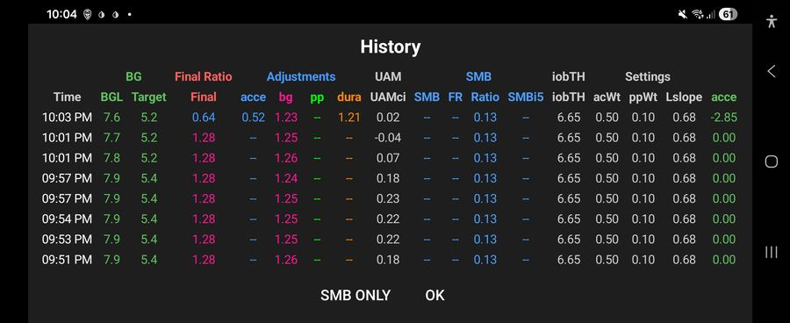


- AIV table popup, automatic backup with logs and settings immediately and 6 hourly
Long-pressing the ISF/history control opens the AIV history popupEach row presents grouped glucose/raw-delta, ISF-factor, insulin/carb/HP, request/delivery and activity/status fields
Each row joins the nearest available context to an AIV timestamp and presents grouped glucose/raw-delta, ISF-factor, insulin/carb/HP, request/delivery and activity/status fields Manual/on-open and Automatic /export ; all export AIV csv, text, setting txt, userentries.csv, logarithmic zip End [↑ TOC]

Introduction: Most significant new features [↑ TOC]
This is the plain-language companion to the full AutoISF Operations Manual -- same section numbering, same headings, same settings/reference tables, but each subsection here is one short paragraph explaining what it does and why it matters, instead of the full technical detail. Use this to get oriented quickly; use the full manual [or Plain Language manual] when you need the actual mechanism, thresholds, or code references.
This manual concentrates on the operational changes that most distinguish this AutoISF fork from stock AAPS and that are most likely to affect daily use:

- Full description of the bolus calculator changes; split and delayed bolus, safer calculation;
Changes to bolus calculator with addition,s modificationeg
Initial screen and live calculation., carbs, protein, fat . Protein and fat are not included in the immediate total
Manual split-bolus if bolus over maximum bolus, remainder split
Automatic delayed bolus at 50% or recent-50. This is distinct from the manual split.
- Lists 1 and 2: full descriptions; rapid access to settings
Double-tap the IOB area to open List 1. Double-tap the basal-rate area to open List 2
The outer list shows setting names ; for setting preferences and some functions, with confirmation.
On AAPSClient preferences are not changed locally, so confirmation creates the matching five-minute custom temporary-target code for the pump to receive, apply and cancel.
- Settings Import Features — Especially With States.
Four “Keep current…” checkboxes not present in stock AAPS
Automation States are force-disabled after every import, requiring confirm
Import restores states wholesale — where “states I never made myself” can come from
- AIV table popup, automatic backup with logs and settings immediately and 6 hourly
Long-pressing the ISF/history control opens the AIV history popupEach row presents grouped glucose/raw-delta, ISF-factor, insulin/carb/HP, request/delivery and activity/status fields
Each row joins the nearest available context to an AIV timestamp and presents grouped glucose/raw-delta, ISF-factor, insulin/carb/HP, request/delivery and activity/status fields
Manual/on-open and Automatic /export ; all export AIV csv, text, setting txt, userentries.csv, logarithmic zip
- Mechanism For Ignoring Or Invoking Native Automations; new ones now self-healing for the coded automations' own states.
his fork re-implements roughly 100+ of what used to be native AAPS Automation-tab triggers/actions directly as hand-coded Kotlin blocks
each native Automation-tab event's title against that registry every time it decides whether to actually run a native event
cf explanation of automation toggles gor MJ, Steroid buttons, installation check of cose tuned on for aISF running
- Tier 3 UAM Boost criteria, output limits and duration.
This is not active and only runs on virtual pump at the moment.
Tier3 from Boost variant program with different protection; testing only
- BolusGiven strong-boost effects.
BolusGiven strong boost. This is separate from Tier 3. sets SMB delivery ratio to Mild Boost base + 0.03 It uses delivery change
- BolusGivenMild and Mild Failsafe behavior.
Mild Failsafe applies similar effects BolusGiven/Mild automations run first and can change smb_delivery_ratio, profile percentage, target and weights. AutoISF weighs BG acceleration, post-meal rise, and how long BG has been stable differently depending on the situation -- each has a normal (“resting”) weight and a stronger (“boosted”) one that kicks in when conditions call for extra correction.
- Steroid-management initiation and escalation.
Steroids (e.g. prednisone) sharply and progressively raise insulin resistance for as long as they're active. • GUI: “Steroid Kotlin button” setting Also reachable via a direct TT-code Each step requires the previous step's Automation State + profile match to still hold [or set directly from List1
- The Mounjaro three-day reduced-insulin cycle.
MJ means Mounjaro in this fork The MJ controls implement a reduced-insulin state cycle for the period after a Mounjaro dose, when insulin requirements may be lower and hypoglycaemia risk may be greater Also reachable via a direct TT-code The start button is offered when Automation State MJ is NOMJremains as the configured Low Profile
- Hypoglycaemia warnings and protective overrides.
Hypoglycaemia warning causes and outcomes.
Hypoglycaemia warnings do not automatically mean “cancel MJ and restore 100%”. GentleHypoRisk, AlarmHypo1, AlarmHypo2, the 50% profile machinery, and related HP/HP2 checks can lower acceleration weighting. SMS may also be sent
- GUI display changes.
This graph is always the primary time-aligned display Also reachable via a direct TT-code Secondary graphs (graphs 1-4). Graph 5 is a dedicated main-sized comparison panel Gesture and remote triggers. A basal-area long-press cycles the main graph's display preset and controls the quick visibility of empirical carb line 1. An IOB-area long-press toggles SMB labels, resets the basal display preset to normal
- VirtualPseudoWizard: background real-bolus correction (Virtual Pump, testing only).
It places an actual BS.Type.NORMAL bolus, computed by running the same constrained BolusWizard used by the manual calculator, but entirely in the background — no calculator screen is ever shown This graph is always the primary time-aligned display
- Automation States in use: which states this fork’s coded automations read/write and why.
Appendix F — Automation States In Use ; A reference for every named state this fork’s coded automations
- Fast-rise SMB tapering: the tiered cascade, the separate late taper, and what the AIV export actually shows.
a set of checks for excess insulin SMB size, scaling them down

Contents [↑ TOC]
Introduction: Most significant new features
1. Requirements for “Automation States”
a. It has a master on/off switch, and things silently do nothing when it's off
b. Fixed 2026-08-19: this is now self-healing for the coded automations' own states
c. A second, related gap: declaring the value list still isn't the same as the state having a value
2. Settings Import Features — Especially With States
a. Automation States are force-disabled after every import — by design, not a bug
b. Import restores states wholesale — where “states I never made myself” can come from
c. Four “Keep current…” checkboxes not present in stock AAPS
3. Settings That Materially Affect Day-to-Day Function
a. The SMB delivery brake
b. Tier 3 UAM Boost: criteria, output, and duration
c. The weight system's Resting/Boosted pairs
d. Duration (dura) modifications to the AutoISF algorithm
e. TDD factor / sensitivity toggles
f. The overnight safety-guard architecture
4. Setting: If Steroids Are Needed
a. Turning it on
b. The escalation ladder
5. Mounjaro (MJ): three-day reduced-insulin cycle
a. Starting the cycle
b. Day-by-day state progression
c. What changes while MJ remains active
d. Hypoglycaemia warnings and protective overrides
e. Automatic exit and manual restoration
6. Mechanism For Ignoring Or Invoking Native Automations
a. The reconciliation mechanism
b. The suppression only applies while AutoISF is actually the active algorithm
7. Other Idiosyncrasies Worth Knowing
a. CarePortal note codes as a compact diagnostic language
b. MJ as the fork's other major state machine
c. The AIV/UKFcheck export pipeline has more moving parts than it looks
d. A concrete regression pattern worth remembering
8. Manual controls and AIV history
a. Bolus calculator: screen, calculation and follow-up dosing
b. Lists 1 and 2: mechanism, current status and confirmation
c. AIV table: popup population and backup/export behavior
d. Coded profile roles (Standard/Low): assignment, re-picking, and why it matters
e. Steroid escalation as a third coded role (added 2026-08-23)
9. GUI display changes
a. Graph types and the triggers for each
b. Colour changes driven by AutoISF input
c. Information shown on each graph
d. What the different carbohydrate graphs mean
10. Factors affecting progress and hypoglycaemia outcomes
a. Pod age and pump-type qualification
b. Projected HP at bolus-calculator initiation
c. Effects of 50recent, a 50% profile and a hypo temporary target on progress
d. Hypoglycaemia warning causes and outcomes
11. UKF: formulas, roles and initial comparison assessment
a. The UKF variants and where each is used
b. Formula and full explanation of each
c. Progress of the initial UKF-check assessment and earliest-change question
d. UKF1 for live AutoISF dosing (toggle, added 2026-08-23)
12. Battery 1% automation and profile recovery
a. Battery1pc: action at 1% or below
b. BatteryOver1pc: restoration after recovery
13. SensorAge: aging/new-sensor Libre calibration compensation
a. What it compensates for and how the tiers are built
b. The six age tiers and their symmetry
c. Two independent enable switches
d. Entry/exit gating and interaction with LowRaw24Cal
e. Related sensor/pod-age reminders (notification-only)
14. VirtualPseudoWizard: background real-bolus correction (Virtual Pump, testing only)
a. Why it is not a real carb treatment
b. Entry gating
c. Calculation and delivery mechanics
d. Outcome reporting
15. Fast-Rise SMB Tapering: the Tiered Cascade and the Separate Late Taper
a. Where this sits, and the entry gate
b. The tier ladder: Delta/SDelta bands, BG sub-branches, and multipliers
c. Other branches inside FAST RISE HANDLING: Higher BG, early-morning guard, twilight hours
d. The preceding sibling branches, including Sensor Glitch3
e. The separate late taper and cumulative SMB caps
f. What actually reaches the AIV "FastRise" column
g. Libre-calibration slope compensation (added 2026-08-22)
Appendix G — Current Live Settings Snapshot
Screenshots

1. Requirements for “Automation States” [↑ TOC]
“Automation States” is a generic named state-machine store (its own plugin, its own “States” tab in the UI) shared between native Automation-tab triggers/actions and this fork's own coded automations in Kotlin. Two things make it easy to trip over:

a. It has a master on/off switch, and things silently do nothing when it's off [↑ TOC]
Automation States are a shared memory the coded automations use to track things like whether steroids are active or a low just happened. There's one master switch for the whole system -- if it's off, every automation that depends on a state just quietly does nothing, rather than erroring.

b. Fixed 2026-08-19: this is now self-healing for the coded automations' own states [↑ TOC]
If the app needs a state value that was never registered (say, after an update added a new one), it used to be able to crash. Now it automatically registers anything missing the first time it starts, so this fixes itself instead of needing a manual settings edit.

c. A second, related gap: declaring the value list still isn't the same as the state having a value [↑ TOC]
Declaring which values a state is allowed to hold isn't the same as that state actually holding one yet -- a freshly registered state can still be genuinely empty until something writes to it for the first time.
Also fixed 2026-08-19, same day: the bootstrap now also assigns a safe default CURRENT value, but only for the 5 states where there's real evidence of what “neutral/off” means (never guessed): MJ → NOMJremains, MJstate → MJoff, Steroids → Steroids Off, LowBG → NO50rec, Profile → AllOK. It deliberately leaves Steps, Sleeping, BGLstate, and query_got_up declare-only — no coded automation in this file was ever seen writing the first two (something else owns them), BGLstate has only one enumerated value with no observed “off” counterpart (defaulting to it would wrongly assert a low just happened on every fresh device), and query_got_up is a one-shot signal, not a toggle.
The default is only applied when the state currently has no value at all — it can never overwrite something you (or the import) already set.

2. Settings Import Features — Especially With States [↑ TOC]
Settings import in this fork is substantially more elaborate than stock AndroidAPS. The underlying mechanism is still “clear every SharedPreferences key, then write the file's contents back in” (ImportExportPrefsImpl.doImportSharedPreferences()) — but several fork-specific safeguards sit around that blunt operation.

a. Automation States are force-disabled after every import — by design, not a bug [↑ TOC]
Restoring a settings backup automatically switches Automation States off -- on purpose, not a bug -- since an old backup's states might not match what's really happening on the phone right now (e.g. it might think steroids are still active when they aren't). You confirm and turn it back on manually after checking the states still make sense.

b. Import restores states wholesale — where “states I never made myself” can come from [↑ TOC]
Importing a settings file overwrites every state value at once with whatever that file contains -- not just numeric preferences. So a state you never touched yourself can still change on import, if it happened to be recorded in that particular backup.

c. Four “Keep current…” checkboxes not present in stock AAPS [↑ TOC]
Four checkboxes not found in stock AAPS let you protect specific state values from being overwritten during an import -- useful when you want most of an old backup restored but need today's real current state kept for a few particular things.

3. Settings That Materially Affect Day-to-Day Function [↑ TOC]
The full settings tree (~65 entries) is documented setting-by-setting in the companion “AutoISF Settings Reference”. This section instead highlights the handful whose day-to-day real-world effect is outsized relative to how easy they are to change by accident, or how non-obvious their interaction with something else is.

a. The SMB delivery brake [↑ TOC]
A safety ceiling on how much insulin SMB can deliver in a short window, regardless of what the dosing math would otherwise suggest -- the backstop that limits how aggressive one burst of automated dosing is allowed to get.

b. Tier 3 UAM Boost: criteria, output, and duration [↑ TOC]
An extra dosing boost, Virtual-pump-only, that raises how much insulin the loop is allowed to give during a genuinely fast, unannounced rise. Gated on the rate of rise, acceleration and IOB headroom, with its own stacking-safety limits on top -- never active on a real pump.
Stacking-type criteria (added 2026-08-23). Tier 3 previously had none of the anti-stacking safeguards BolusGiven/BolusGivenMild already had, despite living right alongside them -- traced directly to a real 23 Aug firing that delivered three consecutive doses (09:32/33/34am, no gap at all).
Three additions, borrowed from BolusGivenMild: a 10-minute self-throttle (implemented as an instance-level last-fire timestamp on the DetermineBasalAutoISF class itself, since the file's shared readyToRun()/markRun() throttle map lives on the plugin class, not reachable from Tier 3's own pure-calculation code); the same 2-hour quiet window after a manual bolus or carb entry BolusGivenMild already requires; and BolusGivenMild's own sub-7.5mmol delivery-rate ceiling (blocks re-arming when recent IOB change is already running hot -- over 0.8U/5min -- relative to a still-modest BG). All three sit alongside the existing criteria above, not replacing any of them.

c. The weight system's Resting/Boosted pairs [↑ TOC]
AutoISF weighs BG acceleration, post-meal rise, and how long BG has been stable differently depending on the situation -- each has a normal (“resting”) weight and a stronger (“boosted”) one that kicks in when conditions call for extra correction.

d. Duration (dura) modifications to the AutoISF algorithm [↑ TOC]
The “duration” part of AutoISF's sensitivity calculation -- how long BG has been stable -- has fork-specific tuning on top of the stock algorithm, changing how much a long stable stretch is allowed to loosen sensitivity.

e. TDD factor / sensitivity toggles [↑ TOC]
Settings that let your recent total daily insulin dose influence sensitivity calculations, plus toggles to turn that influence on or off.

f. The overnight safety-guard architecture [↑ TOC]
Several independent guards work together specifically overnight: hard ceilings on how far a value like IOB threshold can shift, escalating anti-stacking limits on SMB delivered close together, and forced switches to a gentler profile late at night. All added after two real overnight low-BG incidents, each one catching a different failure mode the others missed.

4. Setting: If Steroids Are Needed [↑ TOC]
Steroids (e.g. prednisone) sharply and progressively raise insulin resistance for as long as they're active. This fork has a dedicated, fully worked-out mechanism for it — the most complete example of a “medical-event ladder” anywhere in the codebase, and a reasonable template if a similar mechanism is ever built for another condition (see §5).

a. Turning it on [↑ TOC]
A dedicated on/off switch and profile-escalation path for when you're taking steroids, which sharply raise insulin resistance -- turning it on shifts AutoISF onto a stronger baseline immediately.

b. The escalation ladder [↑ TOC]
Steroid insulin needs typically build up over days, so there's a five-step ladder (110%→130%→150%→190%→250%) you move through manually as resistance increases, each step switching to a correspondingly stronger profile and raising the IOB ceiling.
Step | Profile switched to | iobTH % | bgAccel weight
START (110%) | Steroid Profile110 | 71 | 0.70
INCREASE (130%) | Steroid Profile130 | 73 | 0.70
INCREASE (150%) | Steroid Profile150 | 74 | 0.70
INCREASE (190%) | Current Profile190Real | 75 | 0.70
INCREASE (250%) | Current ProfileReal250 | 76 | 0.70
TURN OFF | Current ProfileReal | 71 | 0.71

5. Mounjaro (MJ): three-day reduced-insulin cycle [↑ TOC]

MJ means Mounjaro in this fork. It does not mean Morning Jog. The MJ controls implement a reduced-insulin state cycle for the period after a Mounjaro dose, when insulin requirements may be lower and hypoglycaemia risk may be greater. The Overview button describes the intended operating period as three days of the configured low-profile strategy; the implementation uses named states and clock-time transitions rather than an exact 72-hour countdown.

a. Starting the cycle [↑ TOC]
A three-day reduced-insulin automation for the days around a Mounjaro (tirzepatide) injection, since insulin needs drop sharply for a short window afterward -- you trigger it manually when you inject.

b. Day-by-day state progression [↑ TOC]
The three days aren't treated identically -- the automation tracks which day of the cycle you're on and adjusts its own thresholds and profile choices as the cycle progresses back toward normal.

c. What changes while MJ remains active [↑ TOC]
While an MJ cycle is running, several other automations (profile switches, overnight guards) deliberately defer to MJ's own reduced-insulin logic instead of fighting it.

d. Hypoglycaemia warnings and protective overrides [↑ TOC]
MJ's reduced-insulin window genuinely raises hypo risk, so extra warning and override paths exist specifically for BG behaviour seen during an active MJ cycle.

e. Automatic exit and manual restoration [↑ TOC]
The cycle ends on its own after the third day, reverting profiles back to normal -- but can also be cancelled manually early if needed.

6. Mechanism For Ignoring Or Invoking Native Automations [↑ TOC]
This fork re-implements roughly 100+ of what used to be native AAPS Automation-tab triggers/actions directly as hand-coded Kotlin blocks inside OpenAPSAutoISFPlugin.kt (the “coded automations” layer described in CLAUDE.md), so they can react every 1-minute loop cycle instead of on the native automation engine's slower tick. Both systems — native Automation-tab events and coded automations — remain fully present in the app at the same time, which creates a real risk of the same logical action firing twice (once from each system) unless something reconciles them.

a. The reconciliation mechanism [↑ TOC]
Since this fork reimplements 100+ native AAPS Automation-tab triggers as hand-coded Kotlin logic, it needs to stop the ORIGINAL native automation from also firing and double-acting. A registry compares every native automation's title against the coded equivalents and suppresses the native one whenever a coded version already covers it.
Match | Meaning | Effect on the native event
EXACT | normalized title equals a coded key exactly | Always suppressed — the coded equivalent is assumed to be running every cycle instead, no user choice involved
CLOSE | one normalized string contains the other, without being exactly equal | Suppressed only if the user hasn't explicitly accepted it via the review popup (below); a prior “accept” decision (persisted per title) lets it run
NONE | no relationship to any coded key | Never touched — runs exactly as stock AAPS would

b. The suppression only applies while AutoISF is actually the active algorithm [↑ TOC]
This suppression only happens while this fork's AutoISF algorithm is the one actually running the loop -- switch to a different algorithm and native automations are free to run normally again.

7. Other Idiosyncrasies Worth Knowing [↑ TOC]

a. CarePortal note codes as a compact diagnostic language [↑ TOC]
Every coded automation leaves a short, consistent CarePortal note (like “BsUp” or “DelOff”) each time it fires, forming a compact log you can read back afterward to see exactly what happened and when. See Appendix D for the full glossary of what each code means.
Code family | Meaning
AVLs / AVLf | AIV local export succeeded / failed
ACEs / ACEf | combined-export (combined<Name>.txt) rebuild succeeded / failed
UKCs / UKCn / UKCf | UKFcheck diagnostic export found matches / ran fine but found nothing / genuinely failed (UKCf can ONLY come from an exception — never means “no findings”)
StB On / StB Off | Steroid Kotlin button feature toggled on/off via its TT-code
SteroidsON / Steroids130…250 / SteroidsOff | each step of the steroid ladder (§5)

b. MJ as the fork's other major state machine [↑ TOC]
Alongside the general Automation States system, MJ has its own separate day-tracking state machine dedicated to its three-day cycle.

c. The AIV/UKFcheck export pipeline has more moving parts than it looks [↑ TOC]
The AIV history export (and the UKF comparison tool) pull from several different sources and reconstruction paths rather than one simple table -- worth knowing before assuming every exported column is a raw, directly-stored value.

d. A concrete regression pattern worth remembering [↑ TOC]
A real bug already happened once from changing an automation's ACTION value without re-checking its own condition for clearing/re-arming against that new value. Worth deliberately checking both sides together whenever retuning a threshold.

8. Manual controls and AIV history [↑ TOC]

a. Bolus calculator: screen, calculation and follow-up dosing [↑ TOC]
The Wizard/QuickWizard bolus calculator handles carbs, protein and fat, offers a manual split-bolus option when a dose exceeds your configured maximum, and can automatically deliver a delayed top-up dose at 50% profile or after a recent low -- plus a “Walking soon” checkbox that halves the immediate dose for anticipated activity.

b. Lists 1 and 2: mechanism, current status and confirmation [↑ TOC]
Two quick-access settings menus -- double-tap the IOB icon for List 1, the basal-rate icon for List 2 -- give direct toggles, nudges and actions without navigating the full Settings screen. On a real pump or Virtual these apply immediately; on AAPSClient they relay via a short temporary-target code instead.

c. AIV table: popup population and backup/export behavior [↑ TOC]
Long-pressing the ISF/history area opens a scrollable history table built from AIV records, and separately kicks off a full export (CSV, text, settings, UserEntries, logs) -- both on that open and automatically every six hours regardless.
Command | Relay TT (mmol/L) | Current effect
SMBdel base + mild-Bst | 5.002 / 5.004 | Decrease/increase both SMB-delivery baseline and Mild Boost ratio by 0.01.
Toggle Libre sensor adjustment | 5.006 | Toggle aging-sensor/Libre adjustment on or off.
Toggle boost automations | 5.008 | Toggle the whole boost-automation group on or off.
pp ISF weight - normal | 5.012 / 5.014 | Decrease/increase normal postprandial ISF weight by 0.01.
Acceleration ISF weight - normal | 5.016 / 5.018 | Decrease/increase normal acceleration ISF weight by 0.05.
Duration ISF weight - normal | 5.022 / 5.024 | Decrease/increase normal duration ISF weight by 0.1.
Libre slope - original | 5.026 / 5.028 | Decrease/increase the baseline Libre calibration slope by 0.01.
Libre offset - original | 5.032 / 5.034 | Decrease/increase the baseline Libre calibration offset by 0.05.
SMB offset | 5.036 / 5.038 | Decrease/increase the hard SMB-offset override by 0.1.
Clean graph view | 5.042 | Hide SMB dose labels/arrows and show the plain solid-green view.
Wizard bolus percentage | 5.046 / 5.048 | Decrease/increase the Wizard percentage by five percentage points.
Mild Boost ratio | 5.052 / 5.054 | Decrease/increase Mild Boost ratio alone by 0.01.
pp ISF weight - high | 5.056 / 5.058 | Decrease/increase boosted postprandial ISF weight by 0.01.
Acceleration ISF weight - high | 5.062 / 5.064 | Decrease/increase boosted acceleration ISF weight by 0.01.
Higher-ISF-range weight | 5.068 / 5.070 | Decrease/increase high-BG ISF weight by 0.1.
Peak insulin time | 5.074 / 5.076 | Decrease/increase insulin peak by five minutes.
AutoISF maximum - low BG | 5.080 / 5.082 | Decrease/increase the low-BG AutoISF maximum by 0.1.
AutoISF maximum - normal | 5.086 / 5.088 | Decrease/increase the normal AutoISF maximum by 0.1.
TOD offset 00:00-02:00 | 5.092 / 5.094 | Decrease/increase this time-of-day offset by 0.1.
TOD offset 02:00-04:00 | 5.098 / 5.100 | Decrease/increase this time-of-day offset by 0.1.
TOD offset 04:00-06:00 | 5.104 / 5.106 | Decrease/increase this time-of-day offset by 0.1.
TOD offset 06:00-09:00 | 5.110 / 5.112 | Decrease/increase this time-of-day offset by 0.1.
TOD offset 09:00-12:00 | 5.116 / 5.118 | Decrease/increase this time-of-day offset by 0.1.
TOD offset 12:00-18:00 | 5.122 / 5.124 | Decrease/increase this time-of-day offset by 0.1.
TOD offset 18:00-22:00 | 5.128 / 5.130 | Decrease/increase this time-of-day offset by 0.1.
TOD offset 22:00-00:00 | 5.134 / 5.136 | Decrease/increase this time-of-day offset by 0.1.
Toggle Graph2 carb-model curve | 5.138 | Toggle the empirical/theoretical carb-model curve display.
Cloud logs upload | 5.140 | Zip and send logs to configured cloud storage, otherwise use email.
Toggle Graph5 | 5.142 | Toggle the Graph5 comparison panel.
MJ state manual override | 5.144 / 5.146 | Set MJ to NOMJremains or MJ3.
Profile manual override | 5.148 / 5.150 | Select the configured Standard or Low profile.
Toggle UKFset1 live comparison | 5.152 | Toggle the Virtual-Pump, non-Client live UKFset1 comparison; hidden elsewhere.
Run SensorAge code | 5.156 | Toggle the sensor-age code on or off.
Command | Relay TT (mmol/L) | Current effect
MJ start | 5.158 | Start the confirmed Mounjaro cycle.
MJ restore | 5.160 | Run the confirmed Mounjaro restoration action.
Steroid start | 5.162 | Start the steroid-management sequence.
Toggle MJ Kotlin buttons | 5.164 | Show/hide the MJ buttons.
Toggle Steroid Kotlin button | 5.166 | Show/hide the steroid button.
Steroid 110 to 130 | 5.168 | Run the confirmed steroid escalation to 130.
Steroid 130 to 150 | 5.170 | Run the confirmed steroid escalation to 150.
Steroid 150 to 190 | 5.172 | Run the confirmed steroid escalation to 190.
Steroid 190 to 250 | 5.174 | Run the confirmed steroid escalation to 250.
Steroids OFF | 5.176 | Run the confirmed steroid turn-off action.
AnyDesk restart | 5.178 | Client writes an ADesk Note and uses a five-minute relay TT only if no real TT is active; otherwise Note-only transport preserves the real TT.
AnyDesk restart - local test | 5.180 | Local command test through the real receiver; no NS round-trip or relay TT.
Graph: UKF1 | No relay TT | Local display toggle plus optional Libre slope/offset calibration.
Graph: UKF2 | No relay TT | Local display toggle; calibration is already upstream and remains shown as on.
Graph: UKF3 | No relay TT | Local display toggle plus optional Libre slope/offset calibration.
Graph: Graph5 panel | No relay TT | Local panel toggle; optional BGL-only mode hides insulin activity and the three carb series.

d. Coded profile roles (Standard/Low): assignment, re-picking, and why it matters [↑ TOC]
AutoISF's automations don't hardcode which profile counts as “Standard” or “Low” -- you assign your actual profiles to those two roles once, and every automation reads that assignment live. Re-picking later updates every single automation at once, with no code change needed.
Two real incidents from live AIV/UserEntries data, both traced the same day, that clarify what this system does and doesn't cover. First: a real BasalUp ("BsUp") firing on 23 Aug correctly switched to "Current ProfileReal" rather than the user's newly-created "Current Profile100" -- not a bug, just timing: the Standard role hadn't been re-picked to point at the new profile yet at that exact cycle, confirmed by tracking autoisf_standard_profile_name across every settings snapshot that day, and the very next coded-automation profile switch (the reinstated "Switch to Standard/Low profile now" List 1 row, "PrSt" note) correctly used the new name once the re-pick had landed.
Second, more important: a LATER switch back to "Current ProfileReal" traced to a source literally named "button1" in the UserEntries log -- not "AutoISF code-based profile switch" or "AutoISF: reset to 100%", which is what every one of THIS file's ported automations always logs. "button1" is a native AAPS Automation-tab trigger, configured entirely outside this codebase (Settings -> Automation), with the old profile name typed directly into its own Profile Switch action. No amount of re-picking the coded roles touches it -- it has to be edited by hand in the Automation tab itself.

e. Steroid escalation as a third coded role (added 2026-08-23) [↑ TOC]
The six steroid strength levels are now assignable roles too, the same way Standard/Low already were -- renaming or replacing a steroid profile no longer needs touching any code.

9. GUI display changes [↑ TOC]

a. Graph types and the triggers for each [↑ TOC]
The main graph and up to four secondary graphs can each show a different combination of series (IOB, COB, treatments, and more); a fifth dedicated comparison panel (Graph 5) is also available.

b. Colour changes driven by AutoISF input [↑ TOC]
Graph points are tinted by whichever AutoISF factor (acceleration, BG, postprandial, or duration) is furthest from neutral at that moment, so you can see at a glance what's driving the current sensitivity adjustment -- low-glucose points always show the low-BG colour regardless.

c. Information shown on each graph [↑ TOC]
Each graph panel carries its own fixed extra rows beyond whatever series you've selected -- delta figures, hypo-prediction values, step counts, and similar.

d. What the different carbohydrate graphs mean [↑ TOC]
Several carb-related lines exist and mean genuinely different things -- entered carbs vs. COB vs. a theoretical absorption curve vs. the deviation-inferred “unannounced carbs” estimate -- worth not conflating them.

10. Factors affecting progress and hypoglycaemia outcomes [↑ TOC]

a. Pod age and pump-type qualification [↑ TOC]
Some automations only apply once enough time has passed since the last pod/cannula change, and only on patch-pump-type devices.

b. Projected HP at bolus-calculator initiation [↑ TOC]
The bolus calculator runs its own hypo-prediction safety check every time it recalculates, trimming a proposed dose if the projected low afterward looks too close.

c. Effects of 50recent, a 50% profile and a hypo temporary target on progress [↑ TOC]
A recent-low flag, an active 50% profile, and a hypo temporary target are related but distinct things -- each can independently reduce dosing, and they don't all mean the same thing.

d. Hypoglycaemia warning causes and outcomes [↑ TOC]
Hypo warnings can be triggered by several different, unrelated code paths -- not one single BG threshold.

11. UKF: formulas, roles and initial comparison assessment [↑ TOC]

a. The UKF variants and where each is used [↑ TOC]
“UKF1/UKF2/UKF3” aren't three unrelated things -- they're different combinations of Kalman filtering and Libre-specific smoothing, built for different comparison purposes.

b. Formula and full explanation of each [↑ TOC]
The exact mathematical formula behind each variant is in the full manual -- skip this unless you need the underlying math.

c. Progress of the initial UKF-check assessment and earliest-change question [↑ TOC]
Real-data testing suggests UKF1 reacts to a genuine BG change faster than the standard LibreSpecial smoothing -- but this is still being validated against more real episodes before being trusted for anything beyond comparison. See the next section for the live-dosing toggle this finding led to.

d. UKF1 for live AutoISF dosing (toggle, added 2026-08-23) [↑ TOC]
An opt-in, Virtual-pump-only toggle that swaps AutoISF's own dosing-relevant delta/acceleration numbers for the faster-reacting UKF1 signal instead of the usual LibreSpecial-smoothed one. Because it reacts faster, today's gate thresholds may trip a little earlier than they were tuned for -- a compensation setting exists to correct for that once enough real data justifies a value.

12. Battery 1% automation and profile recovery [↑ TOC]

a. Battery1pc: action at 1% or below [↑ TOC]
If battery drops to 1% or below on a real pump, the app automatically forces a safety profile.

b. BatteryOver1pc: restoration after recovery [↑ TOC]
Once battery recovers above 1% and you're confirmed still on that same safety profile, your normal profile is restored automatically.

13. SensorAge: aging/new-sensor Libre calibration compensation [↑ TOC]
SensorAge (OldSensorAdj in code) overrides the Libre calibration slope/offset (FslCalSlope/FslCalOffset) during known-unreliable stretches of a sensor’s life, tapering back to the user’s configured baseline everywhere else. Unlike most of this fork’s automations it has no dosing effect of its own — it only reshapes the calibrated glucose value that everything else, including dosing, is computed from. Unlike the reminder cluster in §13e below, the core tier-compensation block carries no Virtual-Pump gate at all: it applies identically regardless of pump type.

a. What it compensates for and how the tiers are built [↑ TOC]
Libre sensors read less reliably right at the very start of their life, and again toward the very end -- this automation temporarily adjusts the calibration slope/offset during those windows, tapering back to your normal baseline outside them.

b. The six age tiers and their symmetry [↑ TOC]
Three tiers cover a brand-new sensor's first three days; three more mirror them for the sensor's last three days before expiry -- each pulling the calibration progressively further from baseline the more extreme the window.

c. Two independent enable switches [↑ TOC]
A master switch turns the whole mechanism on or off; a second, narrower switch inside it specifically gates the aging (11-15 day) tiers -- both need to be on for any tier to actually apply. The master switch now has a Settings-screen home too, not just List 1.

d. Entry/exit gating and interaction with LowRaw24Cal [↑ TOC]
A separate automation (LowRaw24Cal) takes priority when it's active, temporarily overriding SensorAge entirely. SensorAge itself only ever applies when a genuinely unreliable-BGL pattern has actually been seen recently -- not just because the calendar says the sensor is old.
Real cross-device discrepancy found the same day, still not fully explained. Comparing settings snapshots at the same moment: Client and the real pump-driving device ("Live") both showed old_sensor_adj_active=true and a correctly tiered live FslCalSlope (0.70, stepped down from a 0.72 baseline), while Virtual showed old_sensor_adj_active=false and FslCalSlope stuck at the raw, never-adjusted 0.72 baseline -- despite identical toggle states (both enable switches on) on all three.
Live's own data later showed this ISN'T permanently broken -- a later snapshot from Live showed the SAME stuck-at-baseline pattern Virtual had shown earlier -- suggesting the underlying tier-entry condition (recentHighBglSeen/sensorAgeDays/the tier-boundary match) is genuinely flickering cycle-to-cycle on whichever device, not cleanly broken on one device only. The new diagnostic logging (this paragraph, above) is what's needed to catch a live failure with actual field values -- not yet captured, since the logging hadn't been built onto any device as of this writing.

e. Related sensor/pod-age reminders (notification-only) [↑ TOC]
Separate, notification-only reminders exist for pod/sensor age that don't touch dosing at all -- they just nudge you.

14. VirtualPseudoWizard: background real-bolus correction (Virtual Pump, testing only) [↑ TOC]
VirtualPseudoWizard is different in kind from Tier 3 UAM Boost, BolusGiven, and BolusGivenMild (§3b), which only ever strengthen the SMB delivery ratio. It places an actual BS.Type.NORMAL bolus, computed by running the same constrained BolusWizard used by the manual calculator, but entirely in the background — no calculator screen is ever shown, and no user confirmation occurs. It is a retrospective-testing tool, not a production dosing feature, and is hard-gated twice specifically so it cannot fire on a real pump: once in its eligibility check, and again immediately before the bolus is queued.

a. Why it is not a real carb treatment [↑ TOC]
This automation places a real bolus using a made-up “carbs” number, purely to size a correction dose sensibly through the normal Wizard math -- it isn't recording that carbs were actually eaten.

b. Entry gating [↑ TOC]
Only fires on Virtual Pump, and only under a fairly narrow, specific set of conditions (very high BG, a fast confirmed rise, a sustained pattern) meant to catch a real runaway high that other automations missed.

c. Calculation and delivery mechanics [↑ TOC]
Runs the normal bolus-calculation math in the background and delivers the result automatically, with no user confirmation dialog.

d. Outcome reporting [↑ TOC]
Logs a clear success/failure CarePortal note either way, so it's visible afterward whether it actually delivered.

15. Fast-Rise SMB Tapering: the Tiered Cascade and the Separate Late Taper [↑ TOC]

a. Where this sits, and the entry gate [↑ TOC]
A tiered ladder that decides how much to trim (or not trim) an SMB dose during a fast rise, based on how fast BG is climbing and by how much.
As of 2026-08-22, rawDelta1Mgdl — the single-minute *raw, unsmoothed* delta — was removed from every gate in this cascade, and the code now carries an explanatory comment at the point where the old check used to sit. The removal was driven by real AIV data from two same-day sustained-rise events (01:50–01:58 and 02:50–02:55): at every single sampled minute of both events, rawDelta1Mgdl read negative or flat (as low as -0.56 mmol) even while Delta, SDelta and rawDelta5Mgdl all clearly confirmed a genuine, sustained rise the whole time.
A single unsmoothed one-minute raw reading is simply too noise-prone to be a reliable confirmation on top of signals that already agree — requiring it was silently blocking the entire cascade during exactly the kind of gradual sustained rise it exists to catch. rawDelta5Mgdl (the 5-minute raw delta) was kept, since it passed cleanly at both real events and still gives a raw-signal check independent of the smoothed AAPS delta.
Checking the current source confirms the removal is complete: rawDelta1Mgdl now appears only as a function-parameter declaration (default sentinel 9999.0, meaning "no data supplied") and in this explanatory comment — it is not referenced in any condition anywhere in the file any more. aapsDelta1Mgdl, by contrast, remains part of the entry gate (and several sibling branches' gates) throughout.

b. The tier ladder: Delta/SDelta bands, BG sub-branches, and multipliers [↑ TOC]
Different combinations of how fast BG is rising and what BG level it's rising from select a different multiplier applied to the normal SMB size -- steeper or higher rises get less trimming.

c. Other branches inside FAST RISE HANDLING: Higher BG, early-morning guard, twilight hours [↑ TOC]
A few additional special-case branches exist for particularly high BG, early-morning hours, and twilight-hour patterns.

d. The preceding sibling branches, including Sensor Glitch3 [↑ TOC]
Earlier-checked branches, including one for a specific sensor-glitch pattern, take priority over the main tier ladder whenever they match.

e. The separate late taper and cumulative SMB caps [↑ TOC]
Beyond the tier ladder itself, a separate later-stage taper and two cumulative SMB-amount caps (10-minute and 30-minute) provide additional protection against stacking too much insulin in a short window, regardless of which tier fired.

f. What actually reaches the AIV "FastRise" column [↑ TOC]
The exported “FastRise” column reflects exactly which tier/branch fired and its multiplier that cycle, reconstructed by pattern-matching the logged reason text -- it isn't a raw stored value.
One further wrinkle worth flagging for anyone reading exported FastRise values from before 2026-08-22: for four of the tiered-ladder branches — mild fast rise’s three BG sub-branches (0.9/0.85/0.75) and the early fast-rise tier (0.7) — the actual multiplier had been loosened from an earlier value via an inline "was X" comment, and the *first* reason-text line for each was updated to match the new multiplier, but the "CHANGED SIZE X.XXX for ... fast rise X.XXX" label’s own numeral was not — so any AIV export taken before 2026-08-22 shows the *pre-loosening* value (0.855, 0.806, 0.707, 0.608) rather than the multiplier genuinely applied that cycle (0.9, 0.85, 0.75, 0.7 respectively) for those four branches.
The moderate tier’s two upper-BG branches had the opposite mismatch — their labels (0.602, 0.653) already tracked their current 0.6/0.65 multipliers correctly, but the *other*, non-label reason-text line in those two branches was stale (still reading "* 0.8" and "* 0.7"). All six were corrected 2026-08-22 so every logged numeral now matches what’s actually applied — but if you’re reconstructing historical FastRise values from an export taken before that date, the pre-fix numbers above are what you’ll actually see in the file, not the current code’s behavior.

g. Libre-calibration slope compensation (added 2026-08-22) [↑ TOC]
The whole cascade's mmol thresholds are compensated for how far your live Libre calibration slope has drifted from the 0.75 baseline they were originally tuned against -- so the same real-world rate of rise triggers the same tier regardless of calibration drift. This doesn't extend to basal rate or SMB delivery ratio, since neither is a glucose-kinetics measurement.
Flavor | Application ID | Icon | Role
full | info.nightscout.androidaps | standard AAPS | The real, pump-driving install. This is what “Regan” / the primary phone runs.
pumpcontrol | info.nightscout.aapspumpcontrol | pumpcontrol icon | Stock AAPS pump-control-only variant; not actively used by this fork's own device fleet, but still built.
aapsclient | info.nightscout.aapsclient | yellow owl | “Client”-style mirror. Runs its own full loop calculation every cycle (same as full) but with VirtualPump as its selected pump, so nothing it computes is ever actually delivered — it's a live shadow-loop, not just a passive NS viewer.
aapsclient2 | info.nightscout.aapsclient2 | blue owl | A second, independent Client mirror — same mechanism as aapsclient, distinct app/prefs, lets one phone run two separate mirror instances.

End [↑ TOC]

Appendix G — Current Live Settings Snapshot [↑ TOC]
Snapshot source: AutoISF_settings_Live_20260824_155639.txt
Captured: 24 August 2026, 3:56 PM — MAIN_PHONE_LOCAL (Live), full configuration, version 3.4.2.6+aisf321UK_654.
Important: These are point-in-time values captured from the Live device, not recommended defaults. Later app activity, profile changes, imports, or manual edits may change them.
Setting | Live value
main_phone_snapshot_time | 8/24/26 03:56 PM
source | MAIN_PHONE_LOCAL
configuration_flavor | full
configuration_version | 3.4.2.6+aisf321UK_654
configuration_application_id | info.nightscout.androidaps
configuration_profile | Current ProfileReal
Enable alternative activation of SMB always | true
autoISF_max | 2.60
autoISF_max_low | 1.00
autoISF_min | 0.30
autoisf_bgaccel_isf_weight_high | 0.95
autoisf_bgaccel_isf_weight_normal | 0.70
autoisf_boost_automations_enabled | true
autoisf_clean_graph_requested | false
autoisf_custom_automations_enabled | true
autoisf_dura_isf_weight_normal | 2.50
autoisf_fslcal_offset_normal | 1.40
autoisf_fslcal_slope_normal | 0.72
autoisf_libre_offset_orig | 1.40
autoisf_libre_slope_orig | 0.72
autoisf_low_profile_name | Current Profile
autoisf_low_raw_24_override_active | false
autoisf_low_storage_notified | false
autoisf_mild_boost_ratio | 0.21
autoisf_mild_offset_zero_active | false
autoisf_mj_kotlin_buttons_enabled | true
autoisf_old_pod_notified | false
autoisf_old_sensor_adj_active | false
autoisf_old_sensor_adj_enabled | true
autoisf_pp_isf_weight_high | 0.15
autoisf_pp_isf_weight_normal | 0.10
autoisf_sensor_age_code_enabled | true
autoisf_smb_delivery_baseline | 0.13
autoisf_smb_offset_override | 0.80
autoisf_smb_offset_override_enabled | true
autoisf_standard_profile_name | Current ProfileReal
autoisf_steroid_kotlin_button_enabled | true
autoisf_tdd_factor | true
autoisf_tdd_factor_fallback | 1.00
autoisf_tdd_sensitivity | true
autoisf_tod_offset_0002 | 0.00
autoisf_tod_offset_0204 | 0.00
autoisf_tod_offset_0406 | 0.00
autoisf_tod_offset_0609 | 0.00
autoisf_tod_offset_0912 | 0.00
autoisf_tod_offset_1218 | 0.00
autoisf_tod_offset_1822 | 0.00
autoisf_tod_offset_2200 | 0.00
autoisf_uam_boost_enabled | false
bgAccel_ISF_weight | 0.70
bgBrake_ISF_weight | 0.25
boost_bolus_cap | 2.50
boost_max_iob | 1.00
boost_scale_value | 1.00
dura_ISF_weight | 2.50
fslCal_Offset | 1.40
fslCal_Slope | 0.72
graph5_bgl_only | false
half_basal_exercise_target | 6.90
high_temptarget_raises_sensitivity | true
higher_ISFrange_weight | 0.80
iob_threshold_percent | 70
low_temptarget_lowers_sensitivity | true
lower_ISFrange_weight | 0.70
openapsama_enable_autoISF | true
openapsama_smb_delivery_ratio | 0.13
openapsama_smb_delivery_ratio_bg_range | 0.00
openapsama_smb_delivery_ratio_max | 0.50
openapsama_smb_delivery_ratio_min | 0.95
openapsama_smb_max_range_extension | 4.00
pp_ISF_weight | 0.10
show_carb_model_curve | true
show_graph5 | true
split_bolus_enabled | true
split_bolus_interval | 7

End [↑ TOC]

